VPN settings for Windows 7
1. Click the network icon (a) and select Open network and sharing center (b)
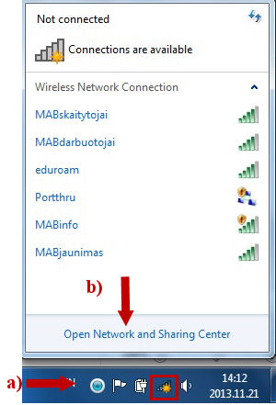
2. In the new window, select Connect to a network
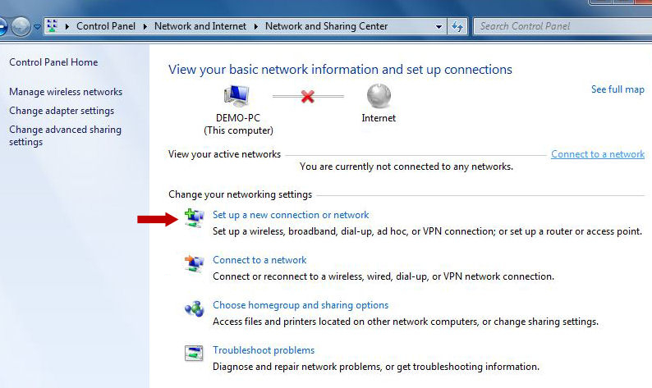

3. Select Connect to a workplace (a) and click Next (b)

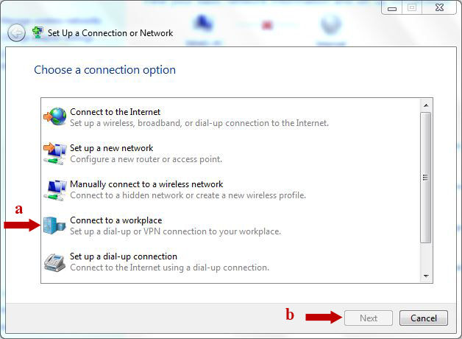

4. Select Use my Internet connection (VPN)

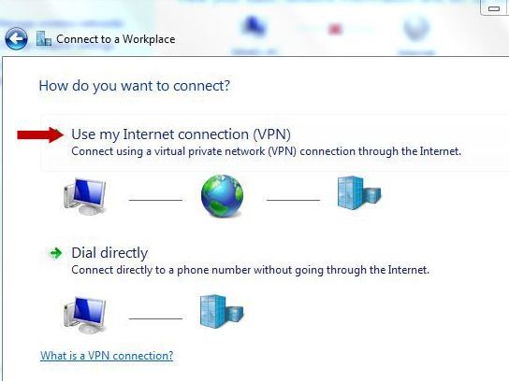

5. Enter vpn.mab.lt (a), MABVPN (b), check Don‘t connect now; just set it up so I can connect later (c) ir and click Next (d)
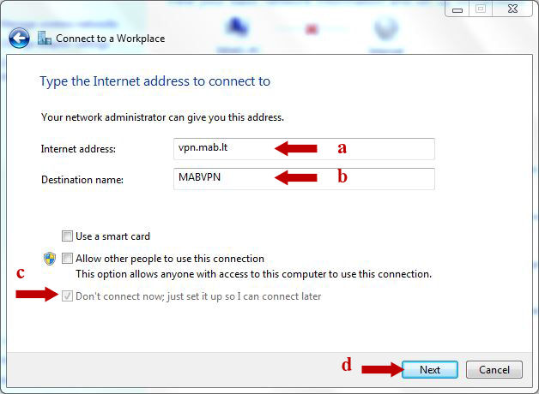

6. Click Create
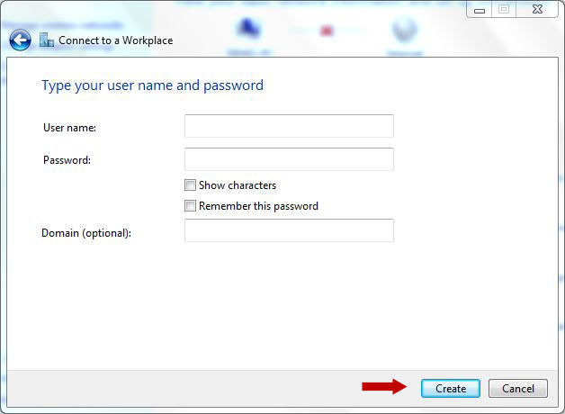

7. Click Connect now
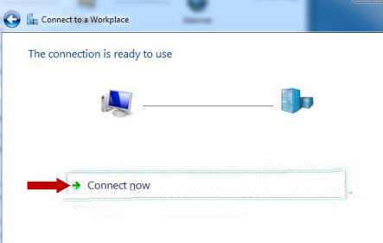

8. In the new window, select Change adapter settings
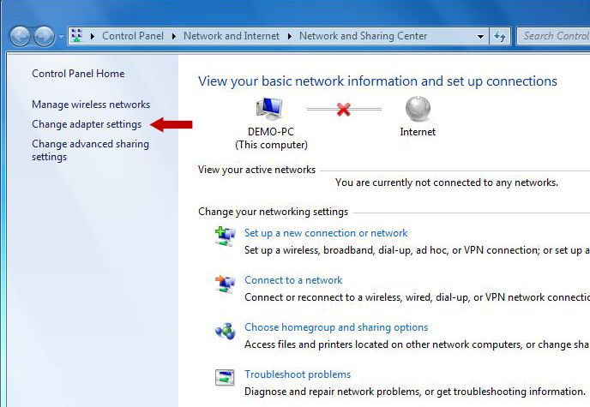

9. Select MABVPN, open the menu with the right mouse button and select Properties
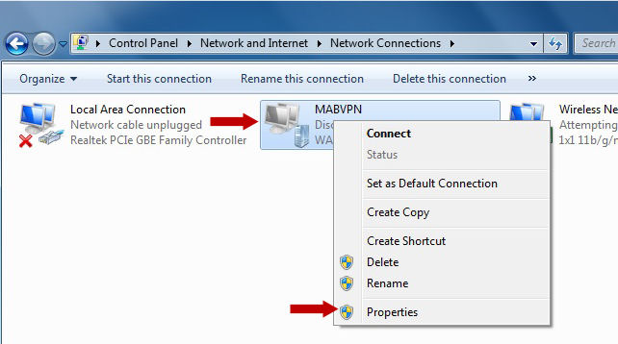

10. Under the Options tab, clear the check box as shown in the following figure:
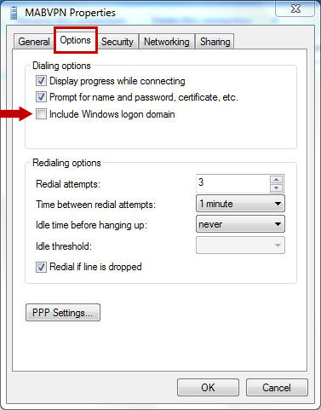

11. Under the Security tab, select Point to point Tunneling Protocol (PPTP) (a), Require encryption (disconect if server declines (b), check Allow these protocols (c), check Microsoft CHAP Version 2 (d) and click OK (e)
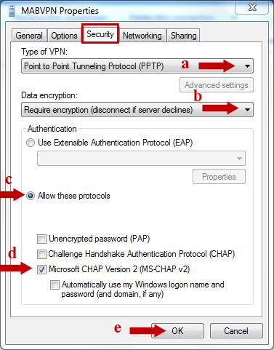

12. Select MABVPN, open the menu with the right mouse button and select Connect
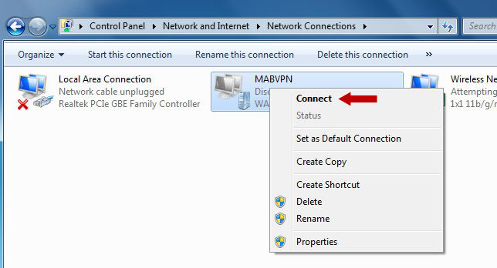

13. In the first field, enter your reader’s card number (a), in the second field, enter your password (b) and click Connect

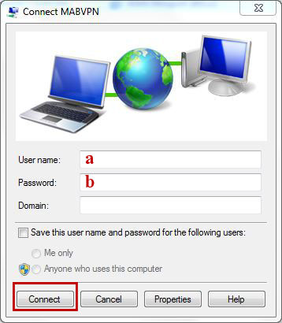

14. When you have finished working, disconnect from MABVPN

Žygimantų St. 1, 01102 Vilnius, Lietuva

