Wi-Fi Settings in Windows 7
1. Click on the network icon (a) and select Open network and sharing center (b)

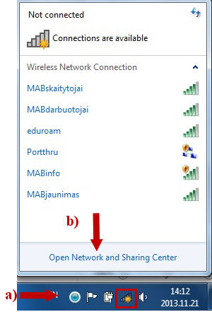

2. In the new window, select Manage wireless networks

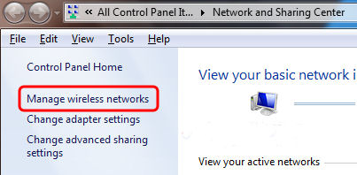

3. Select Add
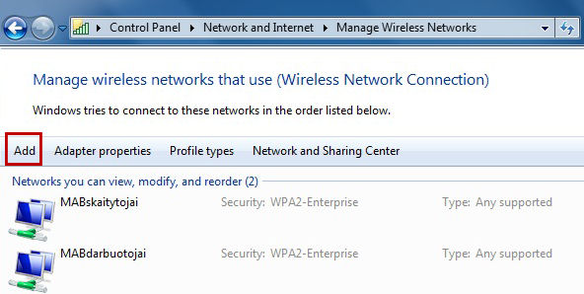

4. Select Manually create a network profile
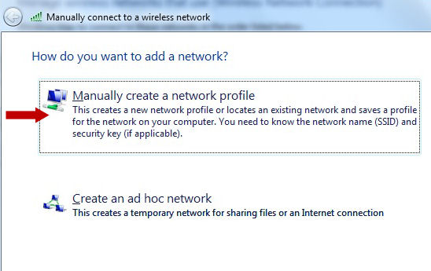

5. In the first field of the new window, enter the network name: MABskaitytojai (a), from the drop-down list below, select the security type: WPA2-Enterprise (b), then select the encryption type : AES (c). Select Start this connection automatically (d) and select Next
Note: If you are under 18 years of age, enter the following network name: MABjaunimas

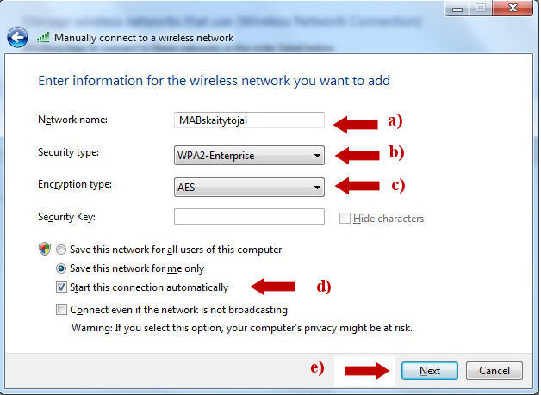

6. Click Change connection settings
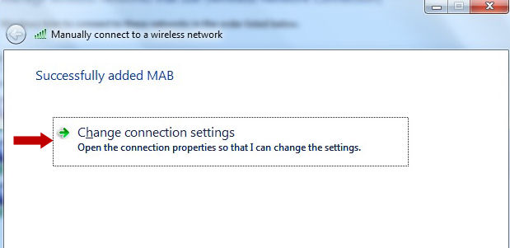

7. In the new window, select the Security tab. Then select:
a) Security type: WPA2-Enterprise;
b) Encryption type: AES
c) Choose a network authentication method: Protected EAP (PEAP);
d) Check the checkbox to avoid entering your credentials each time you log on;
e) Click Settings

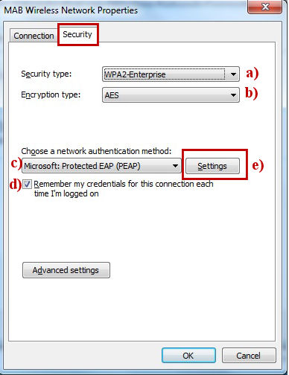

8. Check the check boxes where shown by the arrows and click Configure

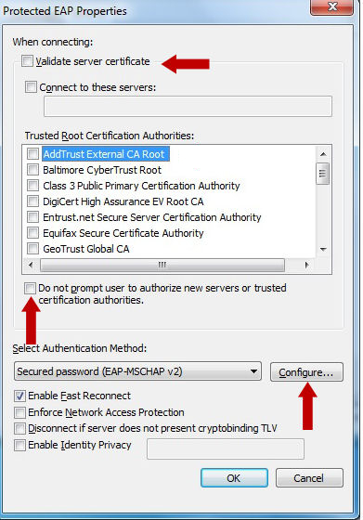

9. In the new window, the check box should be unchecked:

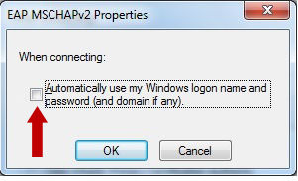

10. Close all the opened windows.
Now the settings have been configured. If you need to log in, keep reading.
11. Click on the network icon. Select the required network and click Connect
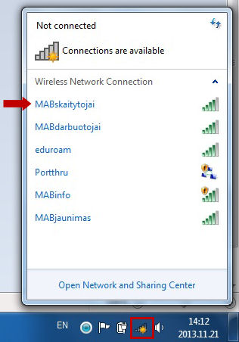

12. In the first field, enter you reader’s card number (a), in the second field, enter your password (b) and click OK (c)

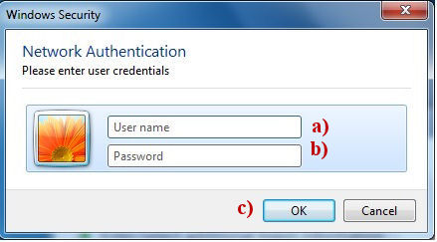
13. After a successful login, clicking on the network icon will display the following image:

